**Validation of FEA Software for Measuring the Natural Frequency of a Thin-walled T5DPP Carbon Fiber Tube.**

Johnathan Le, Vadim Naumchuk, and Jonathan Valencia

ME411 - Instrumentation Measurements

March 10th, 2020

Portland State University

**Introduction**

This report validates the use of Abaqus, a finite element analysis (FEA) software, for determining the natural frequency values of a thin-walled T5DPP carbon tube. T5DPP carbon fiber tubes have a high strength to weight ratio, making it ideal for constructing space-worthy frames. However, due to the presence of intense vibrations in space, there is a concern that the carbon tube could experience vibrations matching its natural frequency, which would negatively impact its structural integrity. Abaqus is more effective than traditional experimental methods in determining the natural frequency values of the carbon fiber tube under different geometric conditions. We used an Inertial Measurement Unit (IMU) to find the natural frequency of the tube when one end is fixed and the other end is free. Using the experimentally found natural frequency, we attempted to validate the use of Abaqus by comparing their results and checking with a theoretical value.

**Experiments & Methods**

To measure the natural frequency of the carbon tube experimentally, we prepared an apparatus consisting of one LSM9DS1 IMU, an Arduino Due, the carbon fiber tube, and a custom made gripper. The apparatus can be seen in Figure 1and details on the carbon tube can be found in Appendix A. We assembled the apparatus so that the center of IMU was aligned with the bottom edge of the tube and oriented so that the Y-axis designated on the IMU was collinear to the tube and pointed towards the top end. Figure 1 showsthe distance between the far right edge of the gripper and the center of the IMU, which made up the experimental length. The gripper was attached at different experimental lengths and the entire apparatus was clamped at the gripper to a surface such that the entire tube was vertical, as

shown in Figure 2**.** The IMU communicated with the Arduino Due via I2C.

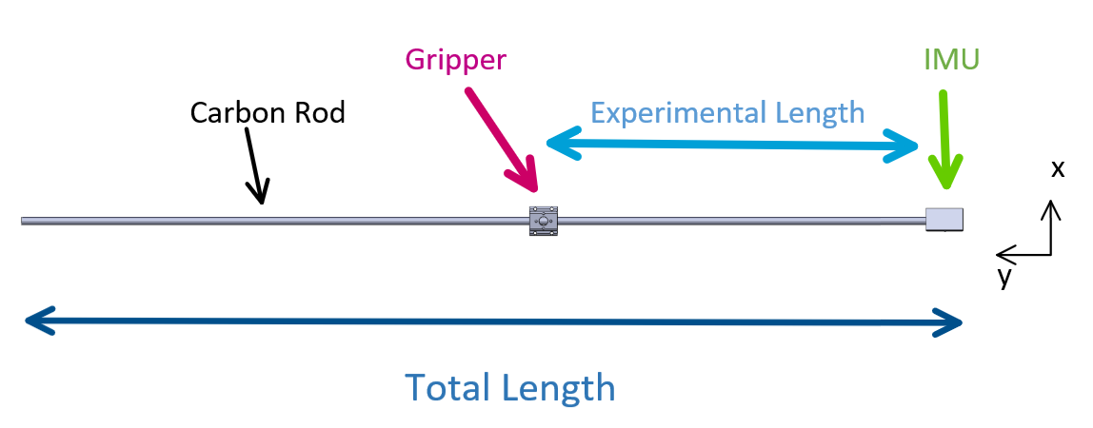

**Figure 1.** Shown is a model of the apparatus consisting of a carbon tube, an IMU, and a gripper. The X-axis and Y-axis are relative to the IMU.

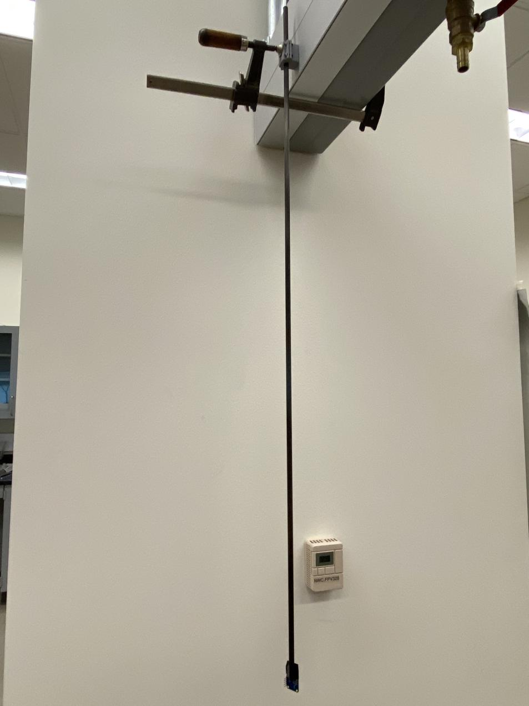

**Figure 2.** Shown is the apparatus used in the experiment from the left side view. (photo V. Naumchuk)

The IMUs measured linear acceleration and radial velocity in the X, Y, and Z directions, but for the purposes of this experiment, we were only recording values in the X and Z directions as there was no movement in the Y direction. For each trial, the recording software measured 1500 points of data at a sampling rate of 110 Hz. After the recording software had activated, the end of the tube was struck whenever the oscillation was near zero. For this experiment, we used three different experimental lengths: 935 mm, 701 mm, and 467 mm. For each length, we ran three trials with additional background noise. An example plot of the raw data is shown in Figure 3.

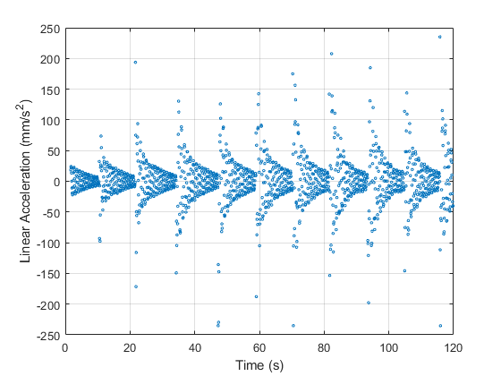

**Figure 3.** A plot of linear acceleration in X direction vs. time of the oscillating tube length of 935 mm.

Our experimental natural frequency, ωn, was calculated using,

**(1)**

where ζ was the damping ratio and ωd was the damping frequency, and in order to get these values, we applied MatLab scripts to analyze our data. Using MatLab, the FFT function was used to determine the damping frequency. Figure 4 shows that the dominant frequency is 9.5 Hz.

Logarithmic decrement, 𝜹, was used to determine the damping frequency, 𝜁, as

(**2)**

**(3)**

A custom MATLAB script was built to select every consecutive peak to apply the logarithmic decrement algorithm which is based on Equation 2. Using the calculated average logarithmic decrement and Equation 3,our script was then able to find the damping ratio.

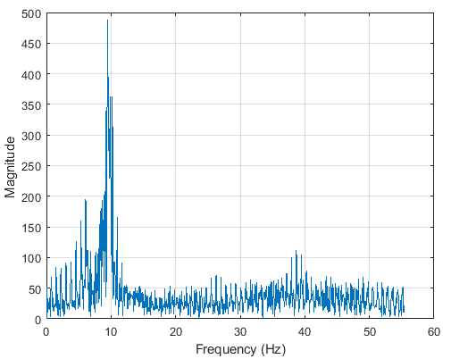

**Figure 4.** Frequency Spectrum plot of linear acceleration in the X direction for a 935mm tube.

To validate Finite Element Analysis, Abaqus is used to find the natural frequencies of an isotropic cantilever tube. Abaqus performs eigenvalue extraction to calculate the natural frequencies and the corresponding mode shapes of the system. To calculate the eigenvalues, the Lanczos solver, which is the default eigenvalue extraction method, was usedas it has the most general capabilities. As to account for the clamp, boundary conditions were set in place to simulate the fixed condition we had in our experiment. The next parameter set in Abaqus deals with the nodal count of the model found in the mesh parameters, for this model hexahedral element type is used. To model the tube used in the experiment refer to appendix B**,** where a detailed step procedure is given.

**Figure 5.** Simulated model of the carbon tube in Abaqus 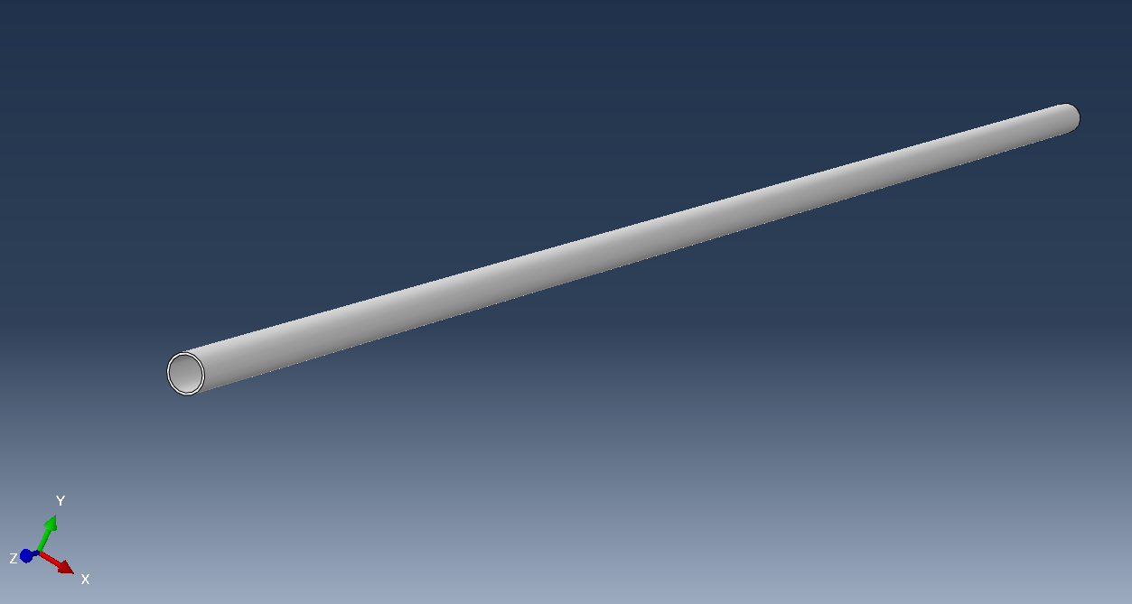

To determine the theoretical natural frequency of a cantilever tube, this report will use the Euler-Bernoulli beam theory [1] to calculate the natural frequency, ωn

(4)

where is the modulus of elasticity, is the moment of inertia of the cross-sectional area, is the length of the bar from the clamped end to the free end, and is the mass per unit length. This theory assumes that there is no damping within the system and the cantilever tube is uniform.

**Results**

Shown in Table 1are our experimental results, comparing linear values with radial values there is only a difference of about 2 percent average for all the runs.

**Table 1.** Experimental results of the natural frequency of the carbon tube for three lengths.

|  |  |  |  |  |
| --- | --- | --- | --- | --- |
|  | natural frequency (Hz) | | | |
|  | radial | | linear | |
|  | X | Z | X | Z |
| 935 | 9.55 | 9.62 | 9.62 | 9.62 |
| 701 | 14.57 | 14.34 | 14.25 | 14.35 |
| 467 | 30.16 | 27.69 | 30.19 | 27.11 |

The theoretical natural frequency for 935mm cantilever tube is calculated with Equation 4 to be 16.5 Hz. For lengths 701mm and 467mm it is calculated to be 29.4 Hz and 66.3 Hz, respectively.

From Abaqus, the frequency response is 17.1 Hz for the 935mm cantilever tube, 30.5 Hz for 701mm and 68.6 Hz for 467mm.

**Discussion**

Comparing the experimental values to the Abaqus values, we initially see a significant error ranging from 44% to 58% for the different lengths. However, when comparing the theoretical results to the Abaqus results, we only have an error averaging 3.5%; we were led to believe that the cause of the large error is due to the inconsistency of the model of the carbon tube used for theoretical and Abaqus methods. Since both non-experimental values differ from the experimental by the same amount. Also, the theoretical model and the Abaqus model use the exact same input values for the carbon tube and get similar results, it is understood that the experimental values are incorrect. As for the source of the error, we believe that the addition of the IMU itself attached to the tube is significantly affecting parameters like mass distribution, and mass moment of inertia. An additional source of error is the gripper and clamp used to fix the end of the tube, allows for the unused remainder of the total length to possibly dampen the frequency

**Conclusion**

Regarding the validation of FEA for measuring the natural frequency of the T5DPP carbon fiber tube, we conclude that FEA is sufficient for predicting the theoretical natural frequency within a 3.5% error. However, in the case of our experimental method, the set up using IMUs has unreliable results and cannot be used as a measurement on the accuracy for Abaqus. To improve the experimental method we would suggest using lighter weight IMUs or a method that does not require direct interference with the vibration of the tube. One example that doesn’t require the attachment of an IMU is using a camera with the capability of recording in slow motion and has a known frame per second recording speed, which is used to find the period of the oscillation visually. Then the period could be used to find a natural frequency.

**References**

[1] S.S. Rao, “Mechanical Vibrations,” *Pearson,* vol. 6, 2015.

[2] R. S. Figliola and D. E. Beasley, *Theory and Design for Mechanical Measurements*. Hoboken: John Wiley & Sons, 2015.

[3] M. N. Horenstein, *Design Concepts for Engineers.* Hoboken, NJ: Pearson, 2016.

[4] “Micro-Measurements.” *Micro-Measurements* A VPG Brand, [www.micro-measurements.com](http://www.micro-measurements.com).

[5] “FFT-Based FIR Filtering.” *FFT-Based FIR Filtering Using Overlap-Add Method- MATLAB,* Mathworks, www.Mathworks.com/help/signal/ref/fftfilt.html.

[6] *Free vibration of a cantilever beam,* The virtual lab at NITC, Surathkal, India. Accessed on: March 7, 2020. [Online]. Available:<http://rtlabs.nitk.ac.in/?q=article/free-vibration-cantilever-beam>

[7] Matthew T. Moraguez, *Cantilever beam: train, load, and uncertainty,* University of Florida, Florida, USA. 2018. Accessed on: March 8, 2020. [Online]. Available:<http://plaza.ufl.edu/moraguezma/cantileverbeammomlab.pdf>

[8] Tretheway, D *Lecture 11: Measuring Strain,* lecture notes, Engineering Measurements ME-411-005. Portland State University, 2020.

**Appendix**

**Appendix A: T5DPP carbon fiber t**

The measurements for the Carbon Tube from the manufacturer used in our theoretical and experimental calculations.

*TABLE 1: T5DPP Carbon Tube data from the manufacturer*

|  |  |  |
| --- | --- | --- |
| **T5DPP Carbon Tube** | **Uncertainty** | **Units** |
| **O.D** | **0.315** | **in** |
| **I.D** | **0.278** | **in** |
| **WT** | **0.0185** | **in** |
| **Length** | **39.4** | **in** |
| **Weight** | **18.1** | **gm** |
| **gm/in** | **0.459** | **gm/in** |
| **Tensile Strength** | **363 ksi/2.50 Gpa** | **ksi or Gpa** |
| **Tensile Modulus** | **20.7 msi/140 Gpa** | **msi or Gpa** |
| **Compression Strength** | **232 ksi/ 1.60 Gpa** | **ksi or Gpa** |

**Appendix B: Details for Abaqus modeling**

The step process used in Abaqus to determine the natural frequency of a carbon tube. This simulation assumes the IMU is negligible in weight with respect to the tube. In Abaqus there are two ways of solving this problem, as a beam or as a solid 3D model, for this case the solid 3D model was chosen as it visually better represents the experiment, however it requires a higher computational power. To model the tube, used in this experiment with a student edition of Abaqus, follow the general steps described below apart from modeling it as a wire beam in 3D space. 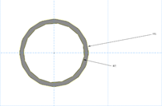

Use consistent units in Abaqus as it is not capable of determining otherwise, for this case the model is represented using mm.

**Dimensions** 8mm Do and 7mm Di extruded 935mm.

**Material properties** 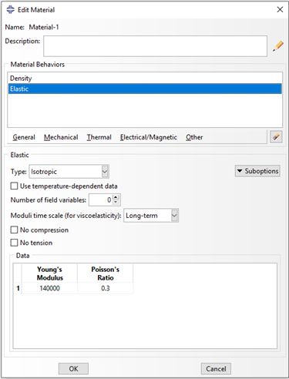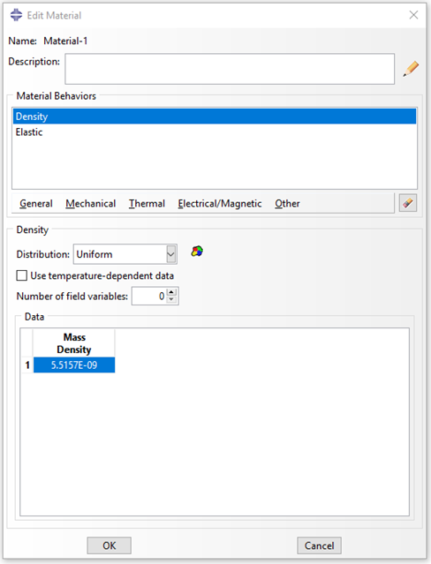

Mass Density: 5.52E-9

Young’s Modulus: 140E3

Poisson's Ratio: 0.3

Next create an instance, followed by setting the step to Frequency in Linear perturbation procedure. Set the Number of eigenvalues 10.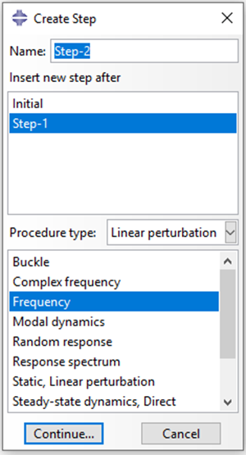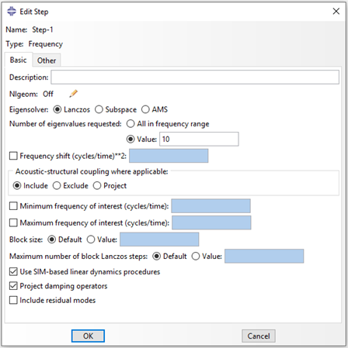

Set the boundary condition, simulating a fixed condition. Preventing any displacements or rotations about each Axis. 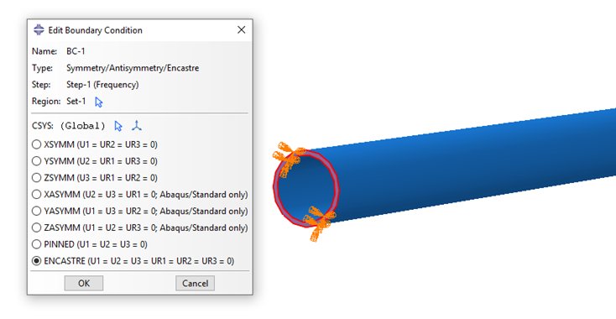

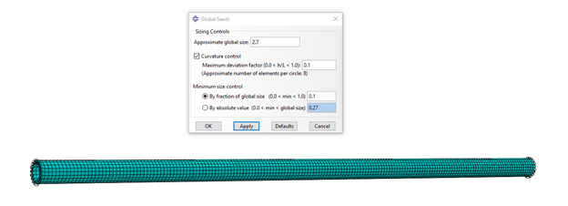

**Followed by Mesh**

In this Model, 2.7 was used as the global size.

Element count for each model based on free length

467mm → 4671 elements

701mm → 7020 elements

935mm → 9342 elements

**Results** Notice Modes one and two represent two axes 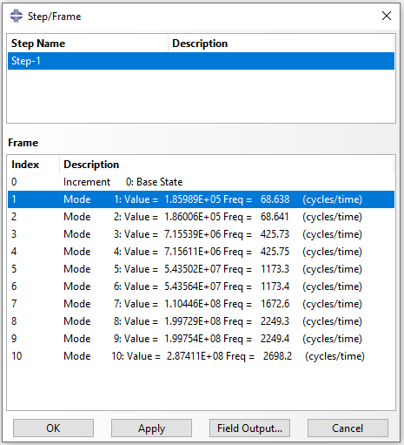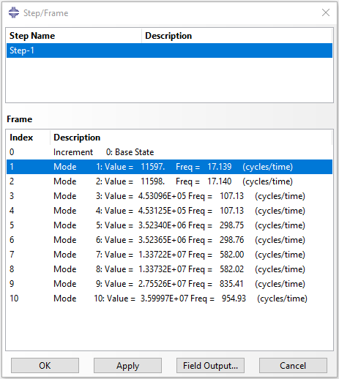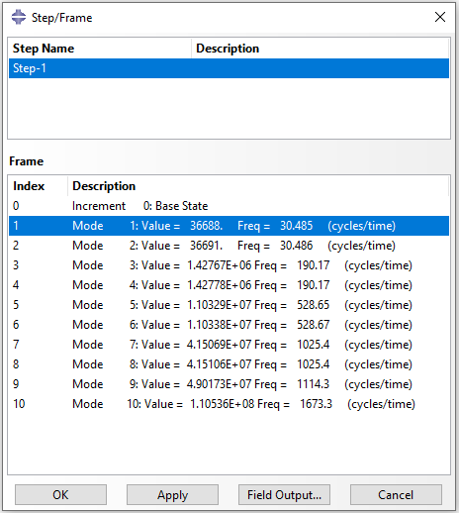

First mode of Frequency for 935mm is 17.139, for 701mm is 30.485, for 467mm is 68.638.